Prepared By –Mayank sharma

📘 Assignment: End-to-End Azure Web App Deployment
Title: Deploy Web API with EF Core + Azure SQL + MVC Client on Azure

🎯 Objective
Build and deploy a complete cloud-based solution using:
- .NET Core Web API
- Entity Framework Core
- Azure SQL Database
- ASP.NET Core MVC
- Azure App Service

🧱 Architecture Overview
MVC App (Frontend)
↓ (HTTP calls)
Web API (App Service)
↓
Azure SQL Database

📝 Functional Requirement
Create a Student Management System
API Features:
- Get all students
- Get student by ID
- Add student
- Update student
- Delete student
MVC App:
- Display list of students
- Add / Edit / Delete using API

🔨 Part 1: Create Web API with EF Core
Tasks:
- Create ASP.NET Core Web API project
- Install EF Core packages
- Create Student model:
  - Id
  - Name
  - Age
  - Course
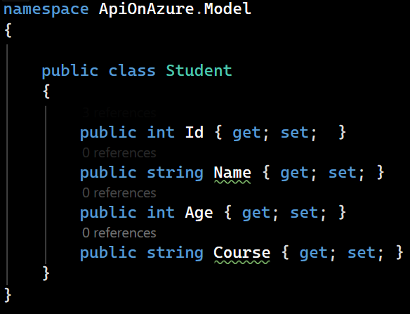
- Create DbContext
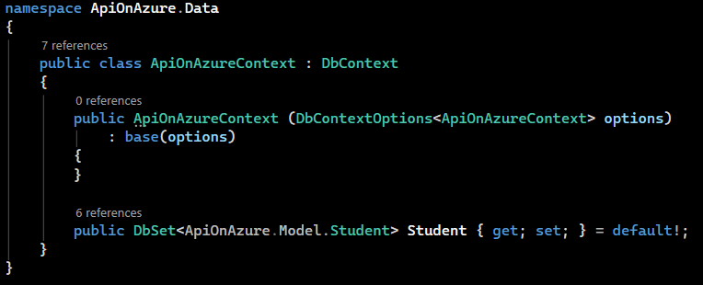
- Configure connection string (local SQL first)
- Add Migration & Update Database
- Implement CRUD API

☁️ Part 2: Create Azure SQL Database
Tasks:
- Go to Azure Portal
- Create:
  - SQL Server (logical server)
  - Database
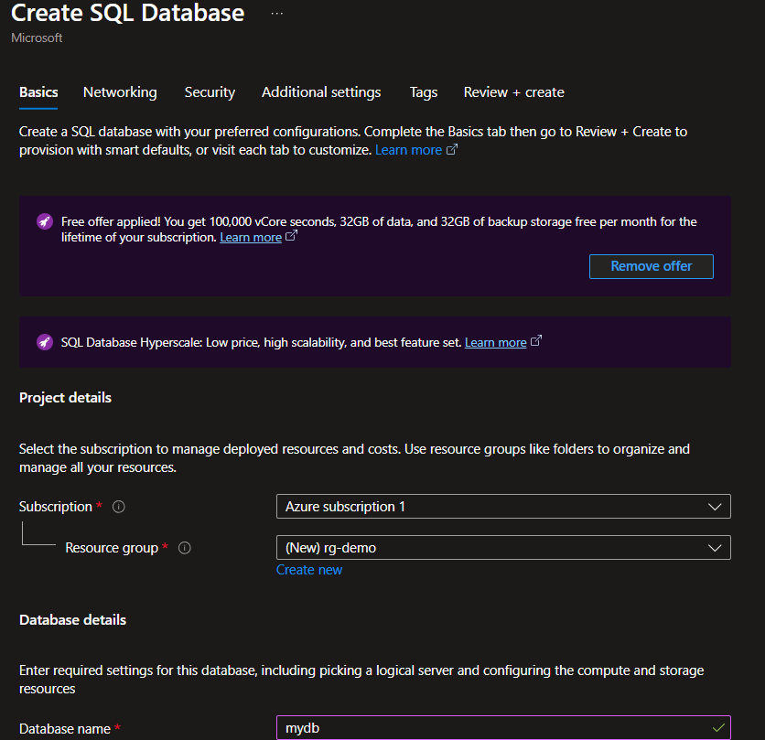
- Configure:
  - Firewall → Allow client IP
  - Authentication (SQL login)
- Copy connection string

🔐 Part 3: Secure Connection String
Update in API project:
"ConnectionStrings": {
"DefaultConnection": "Your Azure SQL Connection String"
}

👉 Best Practice:
- Use Azure Key Vault (optional advanced task)

🚀 Part 4: Deploy Web API to Azure
Tasks:
- Create App Service (Web App)
- Publish API from Visual Studio:
  - Right-click project → Publish
  - Select Azure → App Service
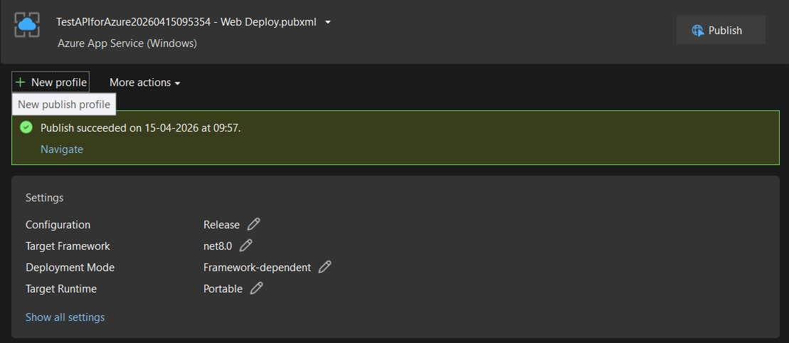
- Configure:
  - App Settings → Connection String
  - Runtime: .NET
- Test API:

🖥️ Part 5: Create MVC Application
Tasks:
- Create ASP.NET Core MVC project
- Create Student ViewModel
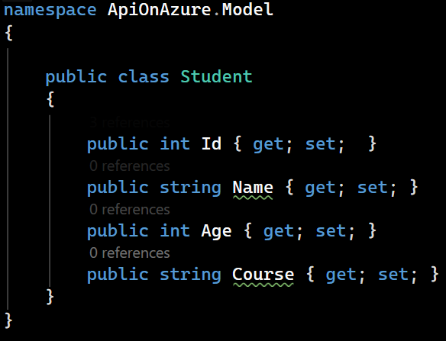
- Call API using:
  - HttpClient
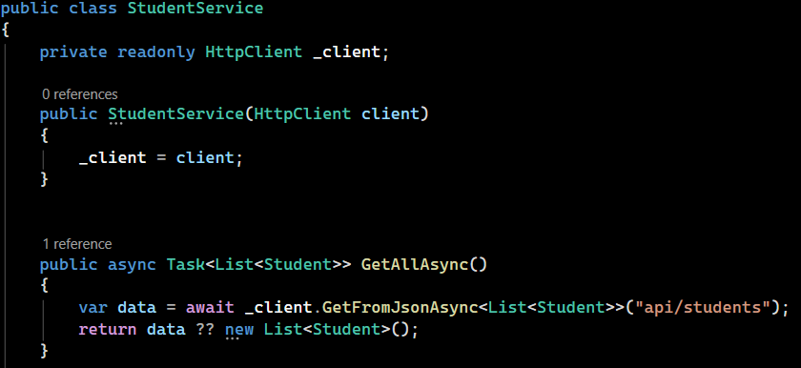
- Implement:
  - Index (list)
  - Create
  - Edit
  - Delete
- Use API URL (deployed one)

🌐 Part 6: Deploy MVC App
Tasks:
- Create second App Service
- Publish MVC app
- Update API base URL in MVC app

🧪 Testing Checklist
- API accessible via browser/Postman
- MVC app loads data from API
- CRUD operations working
- Data persists in Azure SQL

